**Usando el SX1276 LoRa**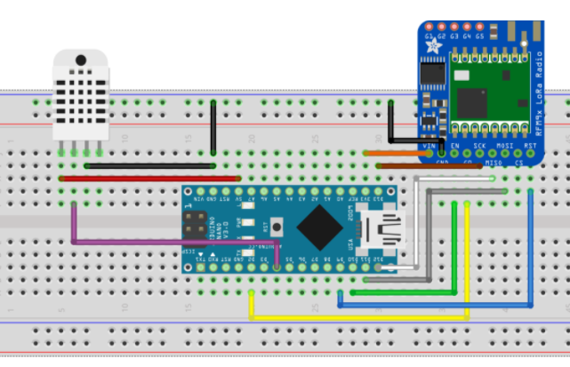

|  |  |
| --- | --- |
| D2 | CO |
| D4 | Senal sensor temp |
| D9 | RST |
| D10 | CN |
| D11 | MOSI |
| D12 | MISO |
| D13 | SCK |
| 3.3 | VIN modulo |
|  |  |
|  |  |

SENDER

**#include <SPI.h>**

**#include <LoRa.h>**

**#include <DHT.h>**

**#define DHTPIN D4 // what digital pin we're connected to**

**#define DHTTYPE DHT11 // select dht type as DHT 11 or DHT22**

DHT dht(DHTPIN, DHTTYPE);

**int** counter = 0;

**void** setup() {

Serial.begin(9600);

dht.begin();

**if** (!LoRa.begin(868E6)) {

Serial.println("Starting LoRa failed!");

Delay(1000);

}

LoRa.setSyncWord(*0xF3*);

LoRa.setTxPower(20);

}

**void** loop()

{

**float** h = dht.readHumidity();

**float** t = dht.readTemperature();

**if** (isnan(h) || isnan(t)) {

Serial.println(F("Failed to read from DHT sensor!"));

**return**;

}

Serial.print("Sending packet: ");

// send packet

LoRa.beginPacket();

LoRa.print("Temp: ");

LoRa.print(t);

LoRa.print(" ");

LoRa.print("Humidity:");

LoRa.print(h);

LoRa.endPacket();

delay(5000);

}

RECEIVER

**#include <SPI.h>**

**#include <LoRa.h>**

//define the pins used by the transceiver module

**#define ss D8**

**#define rst D1**

**#define dio0 D2**

**void** setup() {

Serial.begin(9600);

//setup LoRa transceiver module

LoRa.setPins(ss, rst, dio0);

//replace the LoRa.begin(---E-) argument with your location's frequency

**if**(!LoRa.begin(868E6)) {

Serial.println(".");

**delay(1000);**

}

// Change sync word (0xF3) to match the receiver

// The sync word assures you don't get LoRa messages from other LoRa transceivers

// ranges from 0-0xFF

LoRa.setSyncWord(*0xF3*);

Serial.println("LoRa Initializing OK!");

}

**void** loop()

{

String LoRaData;

**int** packetSize = LoRa.parsePacket();

**if** (packetSize)

{

**while** (LoRa.available())

{

LoRaData = LoRa.readString();

Serial.print(LoRaData);

}

// print RSSI of packet

Serial.print("' with RSSI ");

Serial.println(LoRa.packetRssi());

}

}